## Ksenia Kovaleva 345 Assignment 3 ID: 4716583 UPI: kkov003

# Wireframes

Scenario:

Julie Turner, a 45 year old lawyer is at the office looking over a corporate contract, and she knows she will be staying late this evening. She estimates she has at least another 2 hours until she is done. Her 16 year old daughter Amy texts her to say she is outside the house and she has forgotten her keys at her father’s place. Amy asks her to open the door. Julie has the XYZ website open on her desktop, so she first decides to check that Amy hasn’t brought friends or a boyfriend home with her. She uses the live video footage and zooms in on the view outside the house. Amy is there, alone. Relieved, Julie then accesses the locks and opens the gate and front door for her. She sees that the notifications show the doors are now open. Satisfied, she leaves it up to Amy to close them behind her and goes back to work.

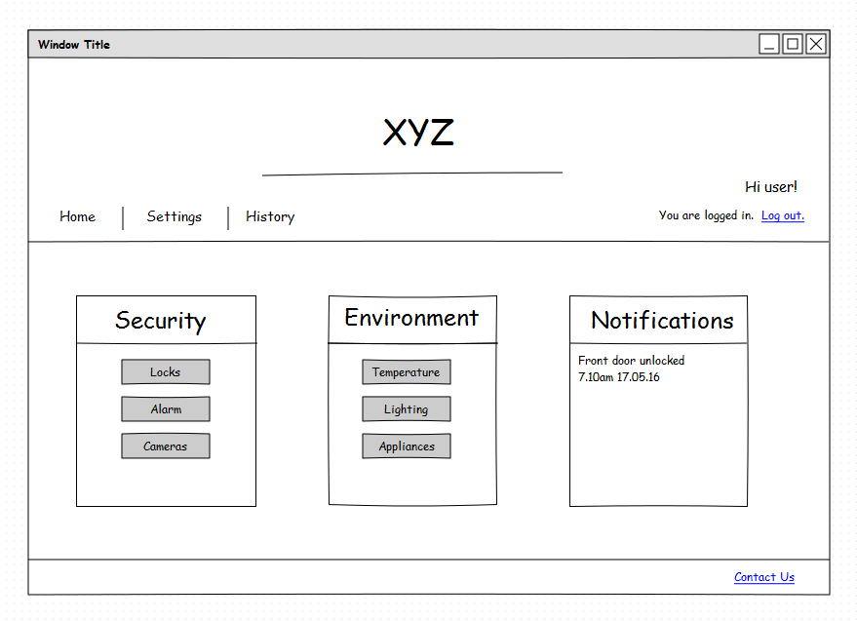

1. Home menu screen (already signed in). Video surveillance is accessed by clicking Cameras which are under the Security heading.
2. 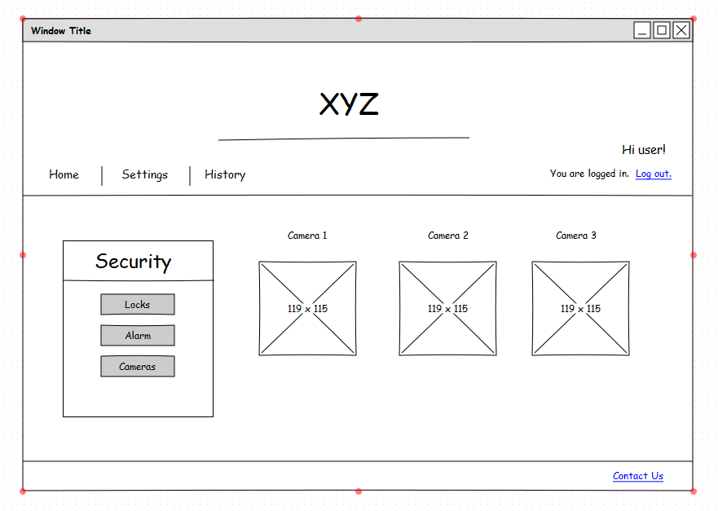Camera has been selected. Display of maximum of 3 cameras on screen at a time with various views. Each video view has an expand button. Press on expand to get a bigger version of that camera view.
3. 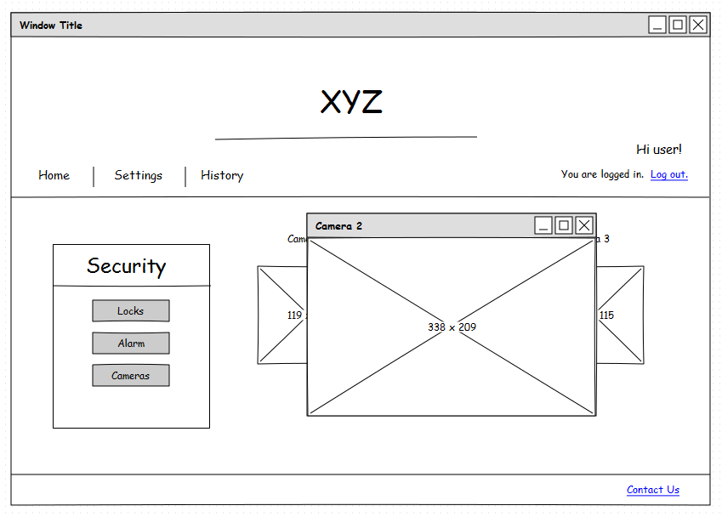Camera 2 is expanded. Clicking close will close the expanded view. To go back to the menu press Home or Cameras.

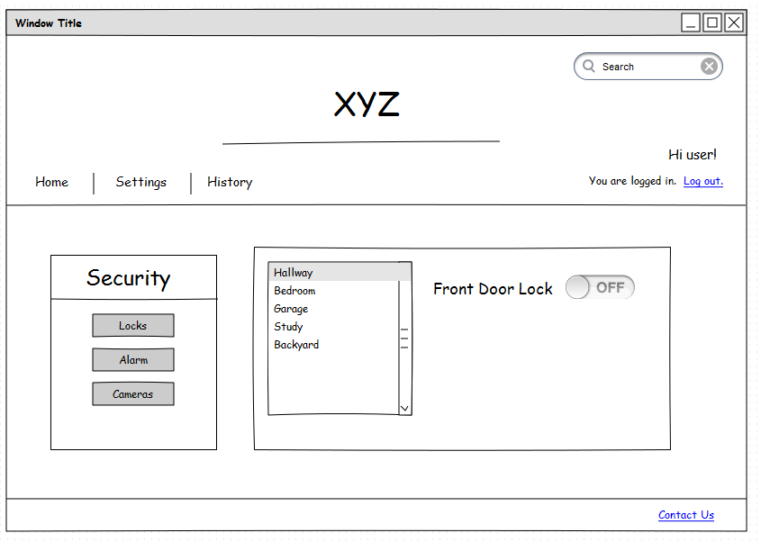

1. Locks menu item is selected. Choose which locks to close by room. Then toggle to lock or unlock. The action will happen instantly (there is no confirmation button).

# 

1. Click locks again or Home to go back to main menu. Notifications are now updated to show that the lock has been locked and when this happened.

# Colour Scheme

The colour scheme used was primarily monochrome along with black and white. It was in done in pale tones of green, based on the pattern of the background of the header. A cover photo concept that would draw the eye in with its pentagon design. The rest of the website reflects that colour scheme. It was chosen to be a soothing, calm colour.

There is also contrast with the vibrant orange of the links when hovered over, which was chosen to act as a highlight for the chosen menu items. It is also a playful way to brighten up the website without visually assaulting the viewer with constant bright colours, if they choose to leave the website open for prolonged periods of time to monitor the house.

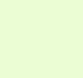 Right most column (notifications).

#EBFDD4

|  |  |
| --- | --- |
| **RGB Decimal** | 235, 253, 212 |

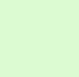 Middle column colour.

#DCFBD2

|  |  |
| --- | --- |
| **RGB Decimal** | 220, 251, 210 |

Colour of the right column menu items (security) and top navigation bar of Home/Settings/History. Also colour of footer.

**#B1F6CB**

|  |  |
| --- | --- |
| **RGB Decimal** | 177, 246, 203 |

 Colour of the clickable menu items when they are hovered over.

|  |
| --- |
| #FFD633 |
| **RGB Decimal** | | 255, 214, 51 |  |

# Layout Scheme

The layout is largely symmetrical. This was done through grouping things in three whenever possible. So three camera views at most are always visible in the camera function. Three main boxes on the home page. Three categories in the top navigation menu. Similarly with locks they are grouped by area such as rooms, but the rooms are themselves split up into downstairs, upstairs and outdoors. This was done so as not to overwhelm the user with unnecessary choice.

Minimum borders were used – colour contrast was used instead of emphasise various areas, thereby making the black font the main focus.

Priority features were situated on the left because most people read left to right – security is left most because it should be the easiest to find since it could be more important and time sensitive than home comforts. Notifications are on the right so as to be unobtrusive.

Icons are on the left beside menu items, so as to enable faster identification of the menu items. A user might identify a symbol without having to read the full description first.

# **Resources**

Google fonts – used for font style.

'https://fonts.googleapis.com/css?family=Playfair+Display'

'https://fonts.googleapis.com/css?family=Roboto:700'

'https://fonts.googleapis.com/css?family=Bitter'

<http://subtlepatterns.com/congruent-pentagon/> - background pattern of header

<http://fontawesome.io/icons/> - Font awesome icons

<http://whoneedsoxygen.net/files/2013/09/backyard-with-pool.jpg> - Image for Camera 3  
<http://www.ferntreedesign.com/blog/wp-content/uploads/2007/05/insideHallway.JPG> - image for Camera 1

<http://cache2.asset-cache.net/xd/1142-15.jpg?v=1&c=IWSAsset&k=2&d=F13A1F9190F00936592AD935DDD95C4D8FC09D10F0E6B04291149829BA49294D2C8AFFA4A0836017> – image for Camera 2